Learn Fly Fishing
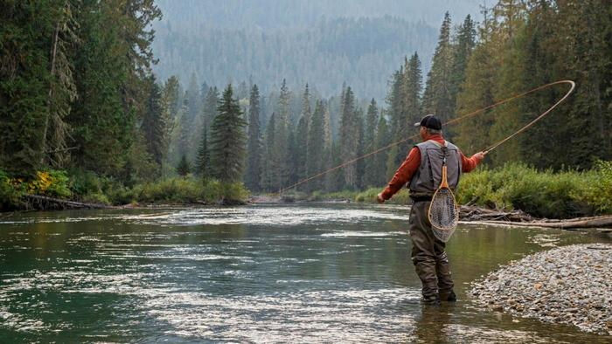

Did you ever want to learn how to fly fish? Have you not fished recently and need some help restarting? Now is your chance. Learn casting, equipment selection, setting up a fly rod, and where to go fish in this area. There is both classroom and on-stream instruction. Classes are held at Ward Pound Ridge Reservation which is ideal since you can go from the classroom straight to the stream. The classes are taught by experienced fishermen from the local Trout Unlimited Chapter. No prior experience and no equipment are required. Fee $150 (with proceeds going to Trout in the Classroom). Class limited to 8. Must be over 18 .

Four Saturday Mornings @ Ward Pound Ridge Reservation

April 4, 11, 18, 25; 8:30 – 12:00 PM; Plus, a Bonus Fishing Day May 2

To Register: https://www.cwctu.org/fly-fishing-school

For more information: Richard.scordato@gmail.com
Sponsored by:
The Croton Watershed Chapter of Trout Unlimited &
The Westchester County Department of Parks.
Tentative Class Curriculum
(Curriculum will adapt to Student Ability and Weather Conditions)

April 4- Classroom/ Outside Casting
  - Registration
  - Fly Fishing Overview
  - Fly Fishing Equipment: Rods, Reels, Fly line etc.
  - Introduction to Casting: Forward Cast
April 11 – Classroom/Outside Casting
  - How to rig a fly rod
  - Knots you need to know
  - Casting: Casting Practice, Roll Cast
April 18– Classroom & Stream
  - Streams & Trout
  - ”Bugs” and Flies
  - How to Fly Fish
  - Introduction to the Stream.
April 25 – Classroom & Stream
  - How to fish
  - Reading Water
  - Mending
  - Playing & Landing Fish
  - On Stream Fishing
May 2 – Special Bonus Trip/ Local Stream TBD
  - Fish a local stream guided by experienced anglers from our local Trout Unlimited Chapter.

